| Course name | Numerical Modelling & Simulation in Scilab Xcos |
| --- | --- |
| **Lesson name** | **Numerical Modelling of Bus using Drive Cycle data in Scilab-Xcos** |
| **Lesson objective** | **Practice blocks &** **acquaint to use GUI of Scilab-Xcos** |
| Created by | Bharath Kumar P |

**Problem statement:** Model Bus for a Drive Cycle in Scilab Xcos to plot the Wheel Torque, Wheel Speed, Motor Torque, Motor Speed and Battery Current in Scilab-Xcos.

**Drive Cycle Graph:**

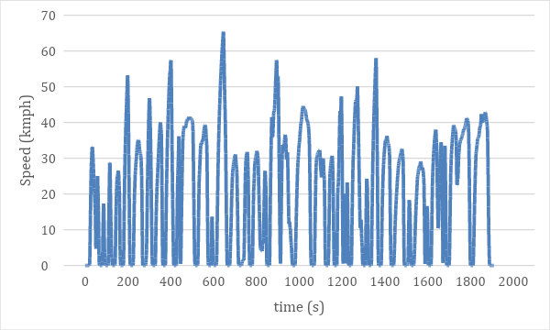

1. **Single Speed Transmission:**

**Vehicle Targets:**

| **Sl No** | **Parameter** | **Value** | **Units** |
| --- | --- | --- | --- |
|  | Vehicle Max Speed | 100 | Kmph |

1. **Two Speed Transmission:**

**Vehicle Performance Requirements:**

| **Sl No** | **Parameter** | **Value** | **Units** |
| --- | --- | --- | --- |
|  | Vehicle Max Speed | 100 | Kmph |
|  | Velocity of Vehicle at Gradeability | 15 | Kmph |
|  | Gradeability Angle | 16 | Degrees |

1. **Model Inputs:**

| **Sl No** | **Parameter** | **Value** | **Units** |
| --- | --- | --- | --- |
|  | 1. **Vehicle Parameters** |  |  |
|  | 1. Gross Vehicle Mass | 10500 | Kg |
|  | 1. Gravity constant | 9.81 | m/s |
|  | 1. Grade Angle | 0 | degree |
|  | 1. Area | 5.46 | m^2 |
|  | 1. Air Density | 1.225 | Kg/m^3 |
|  | 1. Drag Coefficient | 0.35 |  |
|  | 1. Radius of wheel | 0.28575 | m |
|  | 1. **Transmission** |  |  |
|  | 1. Single Speed Transmission | Gear ratio to be identified |  |
|  | 1. Transmission Efficiency | 85 | % |
|  | 1. **Motor** |  |  |
|  | 1. Motor Voltage Constant | To be identified | V/rads |
|  | 1. Motor Resistance | To be identified | Ohms |
|  | 1. Motor Torque Constant | To be identified | Nm/A |
|  | 1. Motor Efficiency | To be identified | % |
|  | 1. **Motor Controller** |  |  |
|  | 1. Motor Controller Efficiency | To be identified | % |
|  | 1. **Battery** |  |  |
|  | 1. Battery Nominal Voltage | To be identified | V |
|  | 1. Battery Initial SOC | 100 | % |

1. **Cell Specifications:**

| **Sl No** | **Parameter** | **Value** | **Units** |
| --- | --- | --- | --- |
|  | **Cell 1: (Pouch)** |  |  |
|  | 1. Peak Voltage | 3.65 | V |
|  | 1. Nominal Voltage | 3.2 | V |
|  | 1. Nominal Capacity | 45 | Ah |
|  | 1. Max. continuous discharge | 135 | A |
|  | 1. Length | 0.275 | m |
|  | 1. Width | 0.165 | m |
|  | 1. Thickness | 0.013 | m |
|  | 1. Weight | 0.99 | Kg |
|  | **Cell 2: (Cylindrical)** |  |  |
|  | 1. Peak Voltage | 4.2 | V |
|  | 1. Nominal Voltage | 3.6 | V |
|  | 1. Nominal Capacity | 2.5 | Ah |
|  | 1. Max. continuous discharge | 20 | A |
|  | 1. Length | 0.06485 | m |
|  | 1. Diameter | 0.01833 | m |
|  | 1. Weight | 0.045 | Kg |
|  | **Cell 3: (Prismatic)** |  |  |
|  | 1. Peak Voltage | 4.2 | V |
|  | 1. Nominal Voltage | 3.65 | V |
|  | 1. Nominal Capacity | 75 | Ah |
|  | 1. Max. continuous discharge | 150 | A |
|  | 1. Length | 0.148 | m |
|  | 1. Width | 0.101 | m |
|  | 1. Thickness | 0.039 | m |
|  | 1. Weight | 1.18 | Kg |